
Internship Report

Specialty＿Computer Science and Technology ＿＿
Class＿ 20lc ＿
Student No.＿2011561103＿＿
Name＿MD MUSTAFIZUR RAHMAN

Internship date from April to May

Contents
Graduation internship task - 1 -
Contents - 2 -
1 First week internship report - 2-11 -
2 Second week internship report - 12-22 -
3 Third week internship report - 23-32 -
4 The fourth week internship report - 33-39 -
5 Internship summary - 40-42 -
Internship report score sheet - 8 -

1. First week internship report

Here you can view the first week of my internship. It was my job to read the materials and conduct any necessary Git or Git Hub research. But I don't know anything about git. Therefore I made an effort to comprehend gits foundations. I learn a lot about git and the issues with git or GitHub after conducting some research.GitHub and Git are primarily two different ideas. GitHub is a website and cloud-based service that initially allows all developers to store and manage their code in one place and track and manage changes to all of the code in one place. It is a platform for hosting code that enables team collaboration and management of all code versions.In this instance, Git is utilized for development and version control, and GitHub acts as a platform or hosting service for hosting code. Before we can create bugs, make changes, request pull requests, etc. in that repository, someone must first create a branch.

About GitHub Issues

GitHub Issues is a feature within the GitHub platform that allows users to track and manage bugs, enhancements, and other tasks related to a specific software project. It is an essential tool for developers and project maintainers to collaborate, prioritize work, and keep track of progress. Users can create issues to report problems, suggest new features, or discuss improvements to existing features.

Key aspects of GitHub Issues include:

1.Issue creation: Users can create an issue by providing a title, description, and optionally attaching labels, milestones, or assigning the issue to a specific team member. The description should be clear and concise, explaining the problem or proposed feature in detail.

2.Labels: Labels help categorize issues based on their type, priority, or status. Project maintainers can create custom labels to suit their project's needs, making it easier to filter and find specific issues.

3.Milestones: Milestones are used to group issues related to a particular project phase or release. They help manage the project timeline and keep track of progress toward specific goals.

4.Assignee's: Issues can be assigned to one or more team members, making it clear who is responsible for addressing the issue.

5.Comments: Team members can comment on issues to discuss the problem, propose solutions, or provide updates on progress. This enables transparent communication and collaboration within the team.

6.Issue status: Issues can be marked as "Open" or "Closed." Open issues require attention, while closed issues have been resolved or deemed no longer relevant. Closing an issue usually involves providing a resolution comment to explain the outcome.

7.Notifications: Users can subscribe to specific issues to receive notifications about updates or new comments. This helps keep team members informed about ongoing discussions and progress.

GitHub Issues is an essential tool for managing software projects, facilitating collaboration, and ensuring that problems and ideas are addressed in an organized and efficient manner.

What Is GitHub Issues and What Can It Do For You?

GitHub Issues is a feature within the GitHub platform designed to help developers and project maintainers manage and track tasks, bugs, enhancements, and other project-related concerns. It facilitates collaboration, prioritization, and organization of work, making it an essential tool for managing software projects.

Here are some benefits and capabilities of GitHub Issues:

1.Centralized issue tracking: GitHub Issues provides a centralized location to track and manage project-related tasks, making it easy for teams to stay organized and keep everyone on the same page.

2.Improved collaboration: Team members can create, discuss, and manage issues together. This allows for transparent communication, leading to more effective problem-solving and decision-making.

3.Categorization: Labels, milestones, and assignees help categorize and prioritize issues, allowing team members to quickly filter and find relevant issues.

4.Enhanced project management: Milestones provide a way to group related issues and track progress towards specific goals, helping project managers ensure work is on track and deadlines are met.

5.Increased accountability: Assigning issues to specific team members makes it clear who is responsible for resolving each issue, leading to increased accountability and ownership.

6.Notifications and updates: Users can subscribe to issues to receive updates and stay informed about ongoing discussions and progress, ensuring everyone is kept in the loop.

7.Integration with other GitHub features: GitHub Issues can be linked to pull requests, allowing for seamless integration between issue resolution and code changes. Additionally, GitHub's API enables integration with other project management and productivity tools.

In summary, GitHub Issues is a valuable tool that enables efficient management of software projects by improving collaboration, organization, and communication among team members. It helps ensure that bugs, enhancements, and tasks are addressed in a timely and efficient manner, ultimately contributing to the successful completion of the project.

How to Get the Most Out of GitHub Issues

GitHub Issues is a powerful tool for project management and collaboration among developers. Here are some tips to help you get the most out of GitHub Issues:

Use descriptive titles: When creating an issue in GitHub Issues, it's important to use a descriptive title that clearly and concisely summarizes the issue. A descriptive title helps others quickly understand what the issue is about and whether it's relevant to them.

Some best practices for creating descriptive titles in GitHub Issues include:

Be specific: Use specific keywords that accurately describe the issue.

Be concise: Keep the title short and to the point. Avoid using long sentences or unnecessary words.

Use active voice: Use active verbs to make the title more actionable and clear.

Avoid jargon: Avoid using technical jargon or acronyms that may not be familiar to everyone.

Include relevant details: Include relevant details in the title, such as the affected feature, component, or module.

6.Use title case: Use title case (capitalizing the first letter of each word) to make the title easier to read.

Examples of descriptive titles in GitHub Issues include:

. "Unable to login on mobile app with Google account"

. "Bug in checkout process when using promo code"

. "Add pagination to search results page"

. "Improve performance of database query on homepage"

. "Fix broken link in footer of website"

Overall, a descriptive title should provide a clear and concise summary of the issue, making it easy for others to understand and prioritize.

Use labels: Labels are a useful feature of GitHub Issues that allow you to categorize and organize issues. They help you quickly identify the type, priority, and status of an issue, and they make it easier to search for and filter issues based on specific criteria.

Here are some examples of how you can use labels in GitHub Issues:

Prioritization: Use labels to indicate the priority of an issue, such as "High Priority" or "Low Priority". This helps you quickly identify which issues need to be addressed first.

Type of issue: Use labels to indicate the type of issue, such as "Bug", "Feature Request", or "Enhancement". This helps you quickly identify the nature of the issue.

Status: Use labels to indicate the status of an issue, such as "In Progress", "Needs Review", or "Resolved". This helps you keep track of the progress of an issue and avoid duplication of effort.

Severity: Use labels to indicate the severity of an issue, such as "Critical", "Major", or "Minor". This helps you quickly identify the impact of an issue on your project.

Complexity: Use labels to indicate the complexity of an issue, such as "Easy", "Medium", or "Hard". This helps you identify which issues may require more time or resources to address.

You can also create custom labels to meet the specific needs of your project. Using labels consistently and effectively can help you manage your issues more efficiently and collaborate more effectively with your team.

Provide a detailed description: Providing a detailed description is an important aspect of using GitHub Issues effectively. A detailed description should include the following:

Summary: A brief summary of the issue. This should be a clear and concise statement of the problem or feature request.

Steps to reproduce: If possible, provide clear steps to reproduce the issue. This can help others diagnose and resolve the problem more quickly.

Expected behavior: Describe what you expect to happen when the issue is resolved.

Actual behavior: Describe what is currently happening that is causing the issue.

Error messages: If there are error messages, include them in the description.

Screenshots or videos: If appropriate, include screenshots or videos to help illustrate the issue.

Relevant information: Include any other relevant information, such as the version of the software, the operating system, or any other factors that may be contributing to the issue.

Workarounds: If you have found any workarounds or temporary solutions, include them in the description.

Providing a detailed description is important because it helps others understand the issue and work towards a resolution more efficiently. It also helps avoid confusion and duplication of effort. By providing a clear and comprehensive description, you increase the chances of a quick and effective resolution.

Include steps to reproduce: "Include steps to reproduce" is one of the important tips for getting the most out of GitHub Issues. When you encounter a bug or an issue, it is important to include detailed steps to reproduce the problem. This means providing clear and concise instructions for others to follow so that they can experience the same issue you are facing.

Here are some tips on how to include steps to reproduce in GitHub Issues:

Start with a clear description of the problem: Describe the issue you are facing in detail. This helps others understand the context and scope of the problem.

Break down the steps into clear instructions: Write out the steps to reproduce the issue in a clear and concise manner. Be specific about what actions you took and what happened as a result.

Include any relevant details: If there are any specific configurations or settings that need to be in place, mention them. This can help others narrow down the cause of the issue.

Attach any relevant files or screenshots: If there are any files or screenshots that can help illustrate the issue, include them in the issue. This can help others visualize the problem and understand it better.

By including steps to reproduce, you help others understand the issue more clearly and provide a path to resolution. This information can also help developers diagnose and fix the issue more quickly, leading to faster turnaround times and a better user experience.

Use comments to communicate: Using comments to communicate in GitHub Issues means that you can engage in discussions with other project contributors to clarify issues, suggest solutions, or provide updates. Comments are a useful way to communicate and collaborate on resolving issues and to keep everyone in the loop.

When a new issue is created, other contributors can read the description and provide feedback or suggestions in the comments section. The person who created the issue can respond to comments, ask for more information, or provide additional details.

As the issue is being worked on, people can use comments to update others on the progress made or any issues encountered. This helps everyone stay informed and reduces duplication of effort. Contributors can also use comments to discuss possible solutions and agree on the best approach.

Comments are a valuable tool in the GitHub Issues workflow, and they enable effective collaboration among contributors. When used correctly, they help ensure that issues are resolved efficiently, and that everyone is on the same page regarding the progress and status of the project.

Assign the issue:Assigning the issue is the process of assigning a particular issue in a GitHub repository to a specific person who will be responsible for resolving it. When you assign an issue, GitHub notifies the person and adds the issue to their list of assigned issues.

Assigning an issue helps to ensure that nothing falls through the cracks and that issues are resolved in a timely manner. It also helps to clarify who is responsible for resolving the issue, so other team members can direct questions or concerns to the appropriate person.

To assign an issue in GitHub, you can simply click on the "Assignees" section of the issue and select the person who will be responsible for resolving it. If the person is not listed, you can add them as a collaborator to the repository or mention them in the comments to alert them of the issue.

Use milestones: Using milestones in GitHub Issues can be a very useful way to track progress and prioritize issues. A milestone is essentially a container that groups related issues and pull requests together.

Here are some steps to help you use milestones effectively:

Create a milestone: To create a milestone, click on the "Milestones" tab in your repository, then click the "New milestone" button. Give your milestone a name and a due date (if applicable).

Assign issues to a milestone: To assign an issue to a milestone, open the issue and click on the "Milestones" dropdown on the right side of the screen. Select the milestone you want to assign the issue to.

Use milestones to track progress: As you work on the issues assigned to a milestone, you can use the milestone to track progress. You can see how many issues are open, closed, and in progress. This can help you stay on track and identify issues that may need more attention.

Set deadlines: Setting a due date for a milestone can help keep your team focused and motivated. You can use the milestone as a target for completing a set of related issues.

Prioritize issues: By assigning issues to a milestone, you can prioritize them based on their importance and impact on your project. You can also use the milestone to communicate priorities to your team.

Overall, using milestones in GitHub Issues can help you stay organized and focused on your project goals. It provides a simple yet powerful way to group related issues together and track progress toward your milestones.

Use issue templates: Using issue templates in GitHub is a great way to ensure that new issues are properly formatted and contain all the necessary information.

An issue template is a pre-defined structure for an issue that includes fields for specific information, such as a title, description, labels, assignee, and milestones. These templates can be created and customized by repository owners and collaborators to fit their specific needs.

When creating a new issue, a user can select from one of the available templates, which then pre-populates the issue fields with the appropriate information. This can save time and ensure that important details are not forgotten or left out. To use an issue template, go to the repository's settings and click on the "Issues" tab. From there, scroll down to the "Issue templates" section and click "Set up templates." Here, you can create and customize templates for different types of issues.

Once the templates are set up, when a user creates a new issue, they can select the appropriate template from the dropdown menu under "Choose a template." The fields of the selected template will then be pre-populated with the relevant information.Using issue templates can help ensure that all issues are consistently formatted, contain all the necessary information, and are easy to understand. This can ultimately lead to faster and more efficient issue resolution.

Use search and filtering: The "search and filtering" feature of GitHub Issues allows you to quickly find and prioritize issues that are relevant to you. You can use the search bar at the top of the issues page to search for specific keywords, such as a particular bug or feature request. This can be useful if you want to see if a similar issue has already been reported or if you want to find all issues related to a particular topic.

In addition to the search bar, you can also use filtering options to narrow down the issues that are displayed. These filters are located on the right side of the issues page and allow you to filter by a variety of criteria, such as labels, milestones, assignees, and more. For example, you can filter to show only issues that are assigned to you, or only issues with a particular label or milestone.

Using search and filtering can help you quickly find the issues that are most important to you and avoid getting overwhelmed by a long list of issues. It can also help you prioritize your work by focusing on the most critical issues first.

Keep the issue updated: "Keep the issue updated" means that you should regularly update the GitHub Issue with new information, status, and resolution, as the issue progresses. This helps everyone involved in the project stay informed about the current state of the issue, and avoid duplicate effort.

Here are some ways to keep the issue updated:

Provide regular status updates: When progress is made towards resolving the issue, update the issue description and comments to reflect the current status.

Communicate any changes: If the scope or details of the issue change, update the issue description and comments to reflect the new information.

Record the resolution: Once the issue is resolved, update the issue description and comments to document the resolution and any necessary follow-up actions.

Close the issue: When the issue is fully resolved, close the issue to indicate that it has been addressed.

By keeping the issue updated, you can ensure that all team members are on the same page and that the project moves forward efficiently. Additionally, updating the issue helps to provide a clear history of the issue for future reference.By following these tips, you can help ensure that GitHub Issues is a useful and effective tool for managing your projects.

2 Second week internship report

After learning about GitHub issue, I read the entire article at: https://github.com/rhiever/ Data-Analysis-and-Machine-Learning-Projects and select the IRIS Flowers Classification Using Machine Learning problem from the Example Data Science Notebook.In the coming two weeks, we'll use machine language to illustrate the IRIS Flower Issues and learn more about the prerequisites for employing machine learning.
Nowadays, machine learning is practically ubiquitous. Day by day, it's becoming more and more important. Machine learning is used everywhere, from recommending products to robotics that can identify people. Therefore, in this project, we'll build a machine learning "Hello World" that classifies iris flowers

What is Machine Learning?
Machine learning is a subfield of artificial intelligence (AI) that focuses on the development of algorithms and models that enable computers to learn and make predictions or decisions without being explicitly programmed. It involves the study of algorithms and statistical models that allow computer systems to automatically learn and improve from experience or data.
The process of machine learning typically involves the following steps:
Data collection: Gathering relevant data from various sources. This data can include examples, observations, or historical records.
Data preprocessing: Cleaning, transforming, and formatting the collected data to make it suitable for analysis. This step often involves tasks like removing irrelevant information, handling missing data, and normalizing data.
Feature extraction/selection: Identifying and extracting the most relevant features or characteristics from the data. This step aims to reduce the dimensionality of the data while retaining important information.
Model selection: Choosing an appropriate machine learning model or algorithm that best suits the problem at hand. There are various types of models, including decision trees, support vector machines, neural networks, and more.
Model training: In this step, the selected model is trained using the prepared dataset. The model learns patterns and relationships within the data by adjusting its internal parameters based on the provided examples.
Model evaluation: Assessing the performance of the trained model using evaluation metrics, such as accuracy, precision, recall, or F1 score. This step helps to gauge how well the model generalizes to unseen data.
Model deployment: Once the model has been trained and evaluated, it can be deployed to make predictions or decisions on new, unseen data. The model can be integrated into applications, systems, or platforms to provide automated decision-making or predictive capabilities.

Machine learning techniques can be broadly categorized into supervised learning, unsupervised learning, and reinforcement learning. In supervised learning, the model is trained on labeled data, where each example is associated with a known target or output. Unsupervised learning deals with unlabeled data, and the model learns patterns or structures within the data without explicit target values. Reinforcement learning involves an agent interacting with an environment and learning to take actions to maximize a cumulative reward.
Machine learning has numerous real-world applications, including image and speech recognition, natural language processing, recommendation systems, fraud detection, autonomous vehicles, and many more.

What are the types of Machine Learning
Machine learning can be broadly categorized into the following types:
Supervised Learning: In supervised learning, the algorithm learns from labeled data, where each example is associated with a known target or output. The goal is to learn a mapping function that can predict the output for new, unseen input data. Supervised learning algorithms include classification, where the output is categorical, and regression, where the output is continuous.

Unsupervised Learning: Unsupervised learning deals with unlabeled data, where the algorithm learns patterns, structures, or relationships within the data without explicit target values. The goal is to discover meaningful information, such as clusters, associations, or dimensions, in the data. Unsupervised learning techniques include clustering, dimensionality reduction, and anomaly detection.

Semi-Supervised Learning: Semi-supervised learning is a combination of supervised and unsupervised learning. It uses a small amount of labeled data along with a larger amount of unlabeled data for training. The labeled data provides some guidance or supervision, while the unlabeled data helps to capture the underlying structure or patterns in the data.

Reinforcement Learning: Reinforcement learning involves an agent interacting with an environment and learning to take actions to maximize a cumulative reward. The agent receives feedback in the form of rewards or penalties based on its actions. The goal is to learn an optimal policy or strategy that leads to the highest long-term reward. Reinforcement learning is commonly used in areas such as robotics, game playing, and autonomous systems.

Deep Learning: Deep learning is a subfield of machine learning that focuses on artificial neural networks inspired by the structure and function of the human brain. Deep learning models, known as deep neural networks, consist of multiple layers of interconnected nodes (neurons) that process and transform data. Deep learning has achieved significant success in tasks such as image and speech
recognition, natural language processing, and computer vision.

Transfer Learning: Transfer learning leverages knowledge or representations learned from one task or domain and applies it to a different but related task or domain. It allows models to benefit from pre-trained knowledge and reduces the need for large amounts of labeled data in the target task. Transfer learning is especially useful when the target task has limited labeled data.

Online Learning: Online learning, also known as incremental learning or lifelong learning, involves the continuous updating and adaptation of a model as new data becomes available in a streaming fashion. Online learning algorithms process data instances one at a time and update the model's parameters in an incremental manner. This type of learning is suitable for scenarios where the data distribution evolves over time or when real-time decision-making is required.

These types of machine learning can be used individually or in combination, depending on the problem at hand and the nature of the available data. Different types of learning algorithms and techniques are suitable for different tasks, and selecting the appropriate type is crucial for achieving effective results.

How Machine Learning Algorithms Works?

Machine learning algorithms work by analyzing and learning patterns and relationships within data to make predictions or decisions. Here's a simplified overview of how machine learning works:
Input Data: The machine learning algorithm requires input data to learn from. This data can be in various formats, such as numerical values, text, images, or audio.

Data Preprocessing: Before feeding the data into the algorithm, it often needs to be preprocessed. This step involves tasks like cleaning the data, handling missing values, converting categorical variables into numerical representations, and normalizing the data.

Training Data and Labels: In supervised learning, the input data is divided into two parts: training data and corresponding labels. The training data contains the input samples, while the labels provide the desired output or target value for each input. For example, in a spam email classification task, the training data would consist of emails, and the labels would indicate whether each email is spam or not.

Model Selection and Initialization: You choose an appropriate machine learning model based on the nature of the problem and the available data. The model can be a decision tree, support vector machine, neural network, or other types. The model is initialized with initial parameter values.

Model Training: The training process involves feeding the training data into the model and adjusting its internal parameters to minimize the difference between the predicted output and the actual labels. The model learns from the training data by optimizing its parameters through an iterative process known as optimization or learning algorithm. This is typically done using techniques like gradient descent, which adjusts the parameters in the direction that reduces the prediction errors.

Model Evaluation: Once the model is trained, it is evaluated using separate evaluation data that the model has not seen during training. The evaluation data contains input samples without corresponding labels. The model predicts the output for each input, and the predicted values are compared with the actual labels to measure the model's performance using evaluation metrics like accuracy, precision, recall, or F1 score.

Model Optimization and Tuning: If the model's performance is not satisfactory, you can optimize and tune the model by adjusting hyperparameters. Hyperparameters are settings that affect the learning process but are not learned from the data. They include parameters like learning rate, regularization strength, or the number of hidden layers in a neural network. Optimization techniques like cross-validation or grid search can help find the best combination of hyperparameter values.

Model Deployment and Prediction: Once the model has been trained and evaluated, it can be deployed to make predictions or decisions on new, unseen data. The trained model takes the input data, processes it based on the learned patterns and relationships, and produces the predicted output or decision.

It's important to note that this is a high-level overview, and the actual implementation of machine learning algorithms can involve more complexities and variations depending on the specific task, dataset, and algorithm being used.

Benefits of Machine Learning

Machine learning offers several benefits across various domains and industries. Here are some key benefits of machine learning:
Automation and Efficiency: Machine learning enables automation of tasks that would otherwise require human intervention. By automating repetitive and time-consuming processes, machine learning can significantly improve efficiency and productivity. This allows humans to focus on more complex and strategic tasks.

Data-Driven Insights: Machine learning algorithms can analyze large volumes of data and extract meaningful patterns, trends, and insights. These insights can help businesses and organizations make data-driven decisions, identify opportunities, detect anomalies or fraud, and gain a competitive advantage.

Prediction and Forecasting: Machine learning models can make accurate predictions and forecasts based on historical data and patterns. This ability is valuable in various applications such as sales forecasting, demand prediction, financial market analysis, weather forecasting, and resource planning.

Personalization and Recommendations: Machine learning powers personalized experiences and recommendations in areas like e-commerce, entertainment, and content streaming platforms. By analyzing user preferences, behavior, and historical data, machine learning algorithms can provide tailored recommendations and personalized user experiences, enhancing customer satisfaction and engagement.

Improved Customer Service: Machine learning can be applied to customer service and support, enabling chatbots and virtual assistants to provide automated and personalized assistance. Natural language processing (NLP) techniques allow these systems to understand and respond to customer queries, reducing response times, and improving customer satisfaction.

Fraud Detection and Security: Machine learning can help detect fraudulent activities, anomalies, or security threats by analyzing patterns and identifying suspicious behaviors. It can be used in areas such as credit card fraud detection, network intrusion detection, and cybersquatting to enhance the accuracy and efficiency of threat detection systems.

Healthcare and Medical Diagnosis: Machine learning techniques can aid in medical diagnosis, disease prediction, and personalized treatment plans. By analyzing patient data, medical records, and research findings, machine learning models can assist healthcare professionals in making more accurate diagnoses, predicting patient outcomes, and suggesting appropriate treatment options.

Improved Efficiency in Manufacturing and Operations: Machine learning can optimize manufacturing processes, supply chain management, and operations by analyzing data from sensors, IoT devices, and production systems. This helps identify inefficiencies, predict equipment failures, optimize maintenance schedules, and streamline operations.

Exploration of Complex Data: Machine learning enables the exploration and analysis of complex and large-scale datasets that would be challenging for humans to process manually. It can uncover hidden patterns, correlations, and relationships in data that might not be apparent through traditional analysis methods.

Continuous Learning and Adaptability: Machine learning models can adapt and improve over time by continuously learning from new data. This ability allows the models to stay up-to-date with changing patterns and dynamics in the data, leading to improved performance and accuracy.

These are just a few examples of the benefits of machine learning. The potential applications and advantages of machine learning are vast and continue to expand as the technology advances.

Disadvantage of Machine Learning ?

While machine learning has many advantages, it also has some potential disadvantages, including:
Lack of Transparency: One of the major issues with machine learning is that the algorithms can be complex and difficult to understand. This lack of transparency can make it challenging to identify the factors that contribute to a given decision or prediction.

Bias: Machine learning algorithms can also be prone to bias, especially if they are trained on data that is unrepresentative or skewed. This can result in unfair or inaccurate predictions or decisions.

Over-fitting: Over-fitting occurs when a machine learning model becomes too complex and is trained on too few data points, resulting in a model that performs well on the training data but poorly on new, unseen data.
Data Quality: The accuracy and reliability of machine learning models depend heavily on the quality and quantity of the data used for training. Poor quality or insufficient data can lead to inaccurate or incomplete models.

Interpret-ability: Although deep learning models can achieve impressive results, they can be difficult to interpret, making it hard to understand why a given prediction was made.
Cost and Complexity: Developing and deploying machine learning models can be complex and expensive, requiring specialized hardware and software infrastructure, as well as skilled data scientists and engineers.

It is important to be aware of these potential disadvantages when using machine learning, and to take steps to mitigate them where possible.
Introduce of Revisiting the Vaccine Visualizations

Revisiting the Vaccine Visualizations" is a project that aims to provide updated and comprehensive visual representations of vaccination data and related information. As the world continues to battle against various diseases and viruses, vaccines play a vital role in safeguarding public health and preventing the spread of infectious diseases.
This project recognizes the importance of presenting vaccine-related data in a clear, accessible, and visually engaging manner. By revisiting vaccine visualizations, the project seeks to enhance public understanding, facilitate data-driven decision-making, and promote transparency.
The project encompasses a range of visualizations that cover different aspects of vaccines, including:

Vaccination Coverage: Visualizing the percentage of the population that has received a particular vaccine or a series of vaccines. These visualizations can be presented on a global, national, or regional scale to highlight vaccination progress and disparities.

Vaccine Efficacy: Illustrating the effectiveness of vaccines in preventing infections, reducing the severity of symptoms, and minimizing hospitalizations. These visualizations may include comparative data for different vaccines, variants, or age groups.

Vaccine Distribution: Mapping the distribution and availability of vaccines across various locations, such as countries, states, or cities. These visualizations can help identify areas with limited access to vaccines and inform targeted interventions.

Adverse Events Reporting: Visualizing data related to adverse events following vaccination. These visualizations can provide insights into the safety profiles of vaccines and help address concerns by presenting transparent and up-to-date information.

Vaccine Research and Development: Displaying the progress and status of vaccine development efforts, clinical trials, and regulatory approvals. These visualizations can highlight the scientific advancements and collaborative efforts in vaccine research.
The "Revisiting the Vaccine Visualizations" project acknowledges the evolving nature of the global vaccination landscape. It aims to leverage the latest data and scientific knowledge to create dynamic, interactive, and user-friendly visualizations. By doing so, the project seeks to empower individuals, healthcare professionals, policymakers, and researchers with accurate and accessible information, promoting informed decision-making and fostering public trust in vaccines.

3 Third week internship report

Last two week we get basic information about Git Hub and Machine Learning. Second week also we get some idea about Revisiting the Vaccine Visualizations.

Related resources
Here is the original WSJ article that inspired this rework: http://graphics.wsj.com/infectious-diseases-and-vaccines/
Here is an article showing how you can remake the charts in R: http://www.r-bloggers.com/recreating-the-vaccination-heatmaps-in-r/

How to download the data
This notebook assumes that you have downloaded the Project Tycho data and placed it in a directory called data in the directory you ran the notebook. To download the data (instructions from here):
1.Register and login to "Project Tycho"
2.Go to level 1 data, then Search and retrieve data
3.Now change a couple of options: geographic level := state; disease outcome := incidence
4.Add all states (highlight all at once with Ctrl+A (or Cmd+A on Macs)
5.Hit submit and scroll down to Click here to download results to excel
6.Open in excel and export to CSV

Last year, the vaccination debate was all the rage again. "Pro-vaxxers" were loudly proclaiming that everyone should get vaccinated and discussing the science behind it, and "anti-vaxxers" were casting their doubts and still refusing to get vaccinated for personal reasons. Around that time, The Wall Street Journal released a brilliant series of heat maps showing infection rates for various diseases over time, broken down by state. These heat maps easily demonstrated one of the most important facts in the vaccination debate: Time and time again,vaccines work.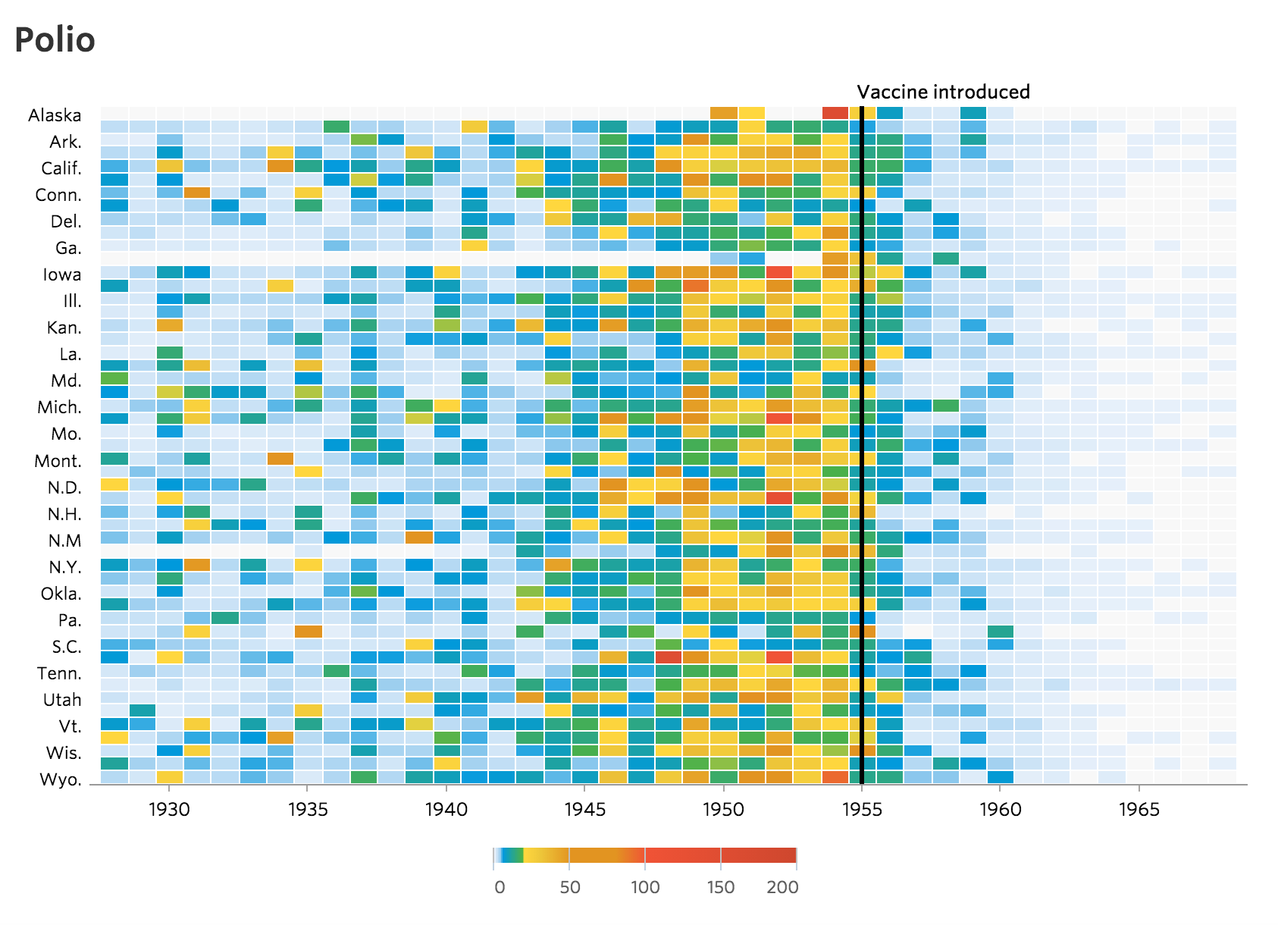Today, I would like to revisit the WSJ's heat maps through the lens of a data visualization practitioner. In particular, I would like to show how these heat maps can possibly be improved upon by reviewing some basic rules of data visualization, and trying out some other methods for displaying the data. Below, I'm going to walk through four major criticisms and show how addressing them can possibly improve the original work.

For the curious, I've released my notebook with the Python code used to generate the new visualizations.

Import all of the libraries we'll be using

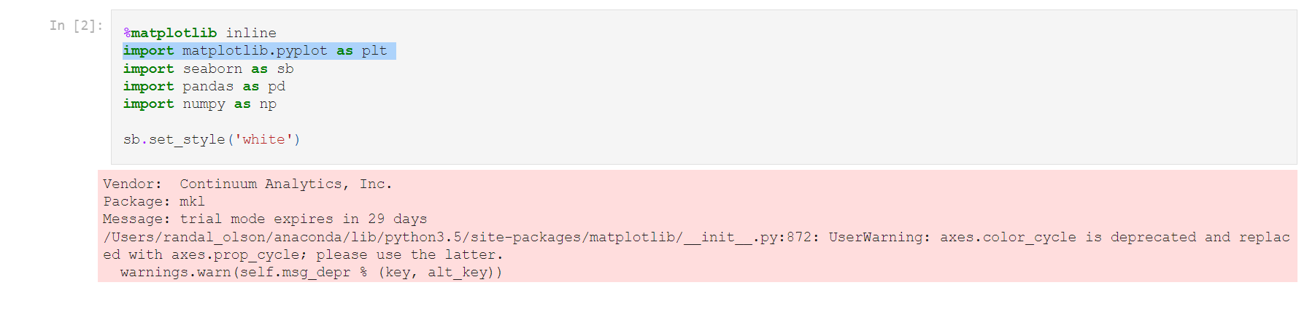

Take a quick look at the data

"Weekly Polio Incidence, 1928-1969"
"Data provided by Project Tycho, Data Version 1.0.0, released 28 November 2013."
YEAR,WEEK,ALABAMA,ALASKA,ARIZONA,ARKANSAS,CALIFORNIA,COLORADO,CONNECTICUT,DELAWARE,DISTRICT OF COLUMBIA,FLORIDA,GEORGIA,HAWAII,IDAHO,ILLINOIS,INDIANA,IOWA,KANSAS,KENTUCKY,LOUISIANA,MAINE,MARYLAND,MASSACHUSETTS,MICHIGAN,MINNESOTA,MISSISSIPPI,MISSOURI,MONTANA,NEBRASKA,NEVADA,NEW HAMPSHIRE,NEW JERSEY,NEW MEXICO,NEW YORK,NORTH CAROLINA,NORTH DAKOTA,OHIO,OKLAHOMA,OREGON,PENNSYLVANIA,RHODE ISLAND,SOUTH CAROLINA,SOUTH DAKOTA,TENNESSEE,TEXAS,UTAH,VERMONT,VIRGINIA,WASHINGTON,WEST VIRGINIA,WISCONSIN,WYOMING
1928,1,0.00,-,0.00,0.00,0.17,0.39,0.00,0.00,-,0.00,0.03,-,0.00,0.03,0.03,0.08,0.00,0.00,0.00,0.00,0.06,0.14,0.04,0.00,0.00,0.03,0.18,0.07,-,-,0.08,0.00,0.08,0.00,-,0.02,0.00,0.64,0.00,0.00,0.06,0.00,0.04,0.05,0.00,0.00,-,0.26,0.06,0.03,0.00
1928,2,0.00,-,0.00,0.00,0.15,0.20,0.00,0.00,-,0.00,0.00,-,0.00,0.01,0.03,-,0.22,0.00,0.05,0.13,0.06,0.14,0.04,0.04,0.00,0.06,0.00,0.07,-,-,0.03,0.00,0.05,0.03,0.45,-,0.04,0.43,0.03,0.00,0.06,0.00,0.04,0.04,0.00,0.00,-,0.39,0.24,0.03,0.00
1928,3,0.04,-,0.00,0.00,0.11,0.00,0.06,0.00,-,0.00,-,-,0.00,0.03,0.03,-,0.00,0.00,0.00,0.00,0.00,0.07,0.02,0.00,0.00,0.03,0.18,0.00,-,-,0.00,0.00,0.03,0.00,0.00,0.06,0.00,1.07,0.02,0.00,0.35,0.00,0.00,0.00,0.00,0.00,-,0.13,0.12,0.03,0.00
1928,4,0.00,-,0.24,0.11,0.07,0.20,0.06,0.00,0.00,0.00,0.00,-,0.00,0.05,0.12,0.00,0.00,0.00,0.00,0.00,0.00,0.02,0.02,0.00,0.00,0.06,0.00,0.00,-,0.00,0.03,0.00,0.06,0.00,0.15,0.00,0.09,0.53,0.02,0.00,0.23,0.00,0.04,0.05,0.00,0.00,-,0.06,0.12,0.00,0.00
1928,5,0.00,-,0.24,0.00,0.32,0.00,0.13,0.00,0.00,0.00,0.00,-,0.00,0.04,0.00,0.04,0.00,0.00,0.00,0.38,0.12,0.02,0.04,0.00,0.00,0.00,0.00,0.15,-,0.00,0.03,0.48,0.07,0.00,0.00,0.03,0.00,0.32,0.00,0.00,0.17,0.15,0.00,0.05,0.00,0.00,-,0.13,0.06,0.03,0.00
1928,6,0.00,-,0.00,0.00,0.22,0.10,0.00,0.00,0.00,0.00,0.00,-,-,0.03,0.00,0.00,0.00,0.00,0.00,0.00,0.00,0.05,0.06,0.00,0.00,0.00,0.00,0.07,-,0.00,0.00,0.00,0.03,0.00,0.00,0.05,0.04,0.21,0.04,0.00,0.06,0.29,0.04,0.00,0.20,0.00,0.04,0.06,0.00,0.14,0.00
1928,7,0.08,-,0.00,0.00,0.13,0.00,0.00,0.00,0.00,0.00,0.00,-,0.22,0.01,0.00,0.00,0.00,0.00,0.00,0.00,0.00,0.09,0.00,0.00,0.00,0.00,0.00,0.00,-,0.21,0.03,0.24,0.02,0.03,0.15,0.05,0.04,0.32,0.01,0.00,0.00,0.00,0.00,0.00,0.40,0.00,-,0.00,0.00,0.07,0.00
1928,1,0.00,-,0.00,0.00,0.17,0.39,0.00,0.00,-,0.00,0.03,-,0.00,0.03,0.03,0.08,0.00,0.00,0.00,0.00,0.06,0.14,0.04,0.00,0.00,0.03,0.18,0.07,-,-,0.08,0.00,0.08,0.00,-,0.02,0.00,0.64,0.00,0.00,0.06,0.00,0.04,0.05,0.00,0.00,-,0.26,0.06,0.03,0.00
1928,2,0.00,-,0.00,0.00,0.15,0.20,0.00,0.00,-,0.00,0.00,-,0.00,0.01,0.03,-,0.22,0.00,0.05,0.13,0.06,0.14,0.04,0.04,0.00,0.06,0.00,0.07,-,-,0.03,0.00,0.05,0.03,0.45,-,0.04,0.43,0.03,0.00,0.06,0.00,0.04,0.04,0.00,0.00,-,0.39,0.24,0.03,0.00
1928,3,0.04,-,0.00,0.00,0.11,0.00,0.06,0.00,-,0.00,-,-,0.00,0.03,0.03,-,0.00,0.00,0.00,0.00,0.00,0.07,0.02,0.00,0.00,0.03,0.18,0.00,-,-,0.00,0.00,0.03,0.00,0.00,0.06,0.00,1.07,0.02,0.00,0.35,0.00,0.00,0.00,0.00,0.00,-,0.13,0.12,0.03,0.00
1928,4,0.00,-,0.24,0.11,0.07,0.20,0.06,0.00,0.00,0.00,0.00,-,0.00,0.05,0.12,0.00,0.00,0.00,0.00,0.00,0.00,0.02,0.02,0.00,0.00,0.06,0.00,0.00,-,0.00,0.03,0.00,0.06,0.00,0.15,0.00,0.09,0.53,0.02,0.00,0.23,0.00,0.04,0.05,0.00,0.00,-,0.06,0.12,0.00,0.00
1928,5,0.00,-,0.24,0.00,0.32,0.00,0.13,0.00,0.00,0.00,0.00,-,0.00,0.04,0.00,0.04,0.00,0.00,0.00,0.38,0.12,0.02,0.04,0.00,0.00,0.00,0.00,0.15,-,0.00,0.03,0.48,0.07,0.00,0.00,0.03,0.00,0.32,0.00,0.00,0.17,0.15,0.00,0.05,0.00,0.00,-,0.13,0.06,0.03,0.00

1928,6,0.00,-,0.00,0.00,0.22,0.10,0.00,0.00,0.00,0.00,0.00,-,-,0.03,0.00,0.00,0.00,0.00,0.00,0.00,0.00,0.05,0.06,0.00,0.00,0.00,0.00,0.07,-,0.00,0.00,0.00,0.03,0.00,0.00,0.05,0.04,0.21,0.04,0.00,0.06,0.29,0.04,0.00,0.20,0.00,0.04,0.06,0.00,0.14,0.00

1928,7,0.08,-,0.00,0.00,0.13,0.00,0.00,0.00,0.00,0.00,0.00,-,0.22,0.01,0.00,0.00,0.00,0.00,0.00,0.00,0.00,0.09,0.00,0.00,0.00,0.00,0.00,0.00,-,0.21,0.03,0.24,0.02,0.03,0.15,0.05,0.04,0.32,0.01,0.00,0.00,0.00,0.00,0.00,0.40,0.00,-,0.00,0.00,0.07,0.00

Visualize the Polio data as a heat-map
Perhaps one of the most straining issues with the original WSJ heat maps was their use of a custom categorical color palette to display the infection rates. The palette runs through most of the colors of the rainbow at seemingly-random intervals. It's possible that they calculated the quantiles to determine the ranges for the color bins (as they should!), but that wasn't indicated in their methodology.

In any case, it's rarely a good idea to use multiple colors to display a single continuous variable. Here, all we want to do is use color to show the infection rates for each year. If we use more than one color, our readers have to constantly refer back to the legend to figure out what each color means, which is an unnecessary cognitive strain on our reader. Instead, we should use a single-color sequential palette, where lighter shades indicate lower values and darker shades indicate higher values. I've reworked the Polio heat map to do just that below.

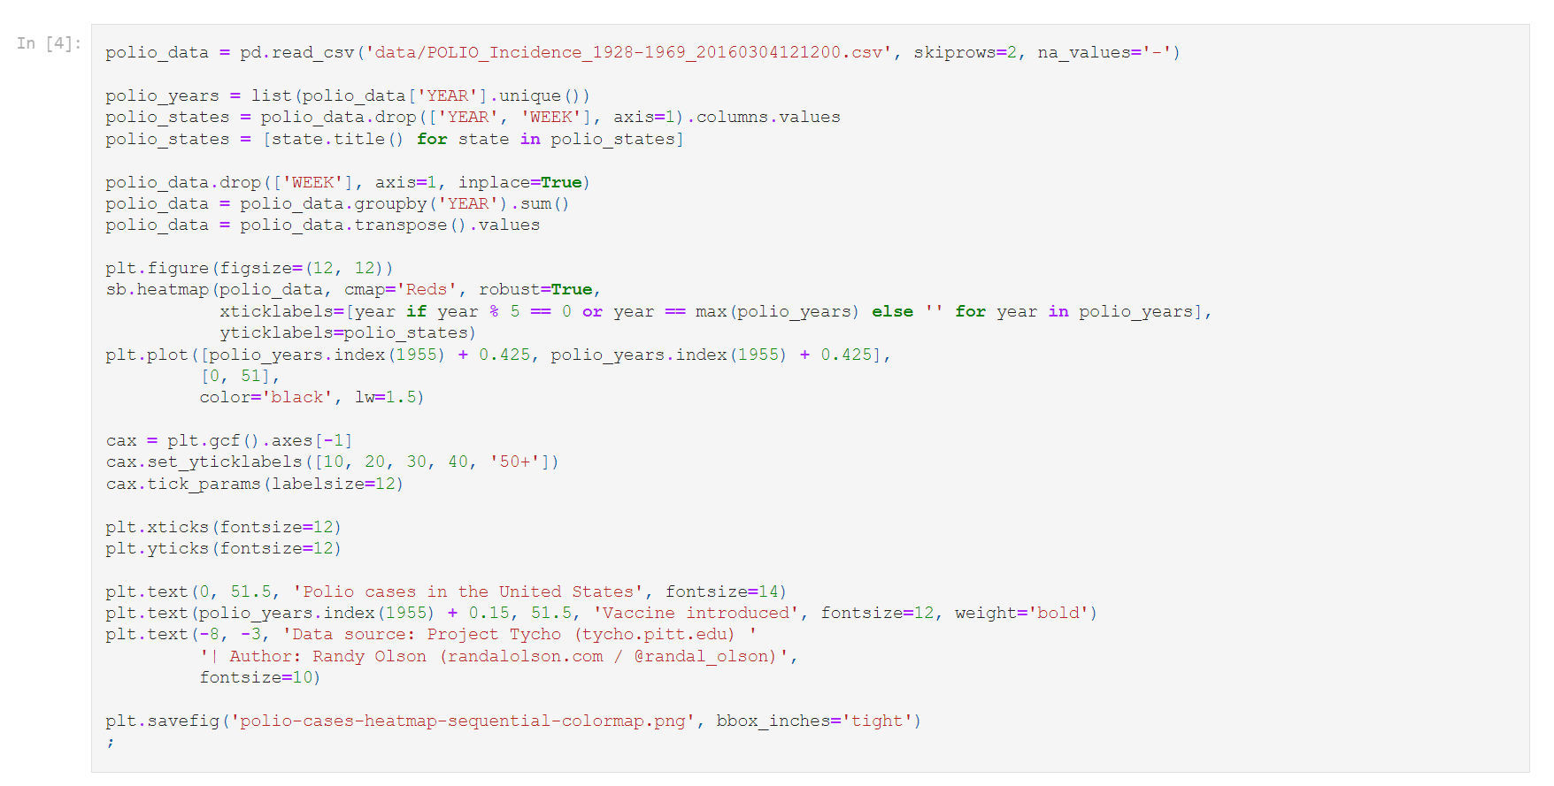

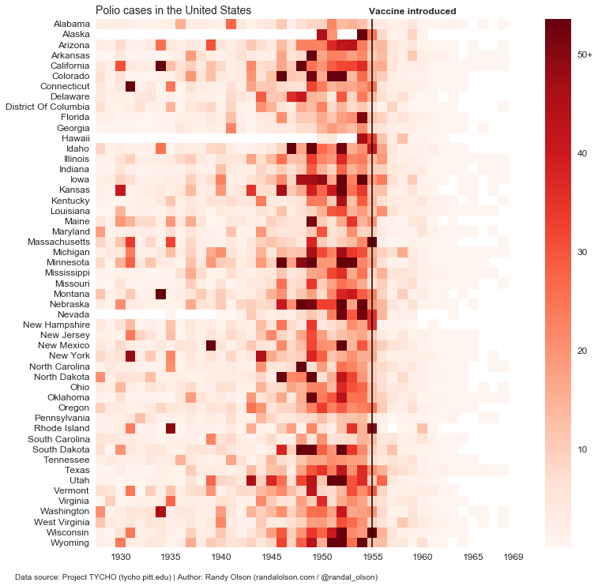

Same process for the Measles data
One exception to this "rule," of course, is diverging color palettes. If there is a clear divide in our continuous variable -- for example, if we're displaying gains and losses for a company -- then it could be appropriate to use a diverging color palette with one color to represent gains (values >= $0) and another to represent losses (values <$0).
Just for fun, I recreated the same chart above for Measles so we can compare it to the originals on WSJ

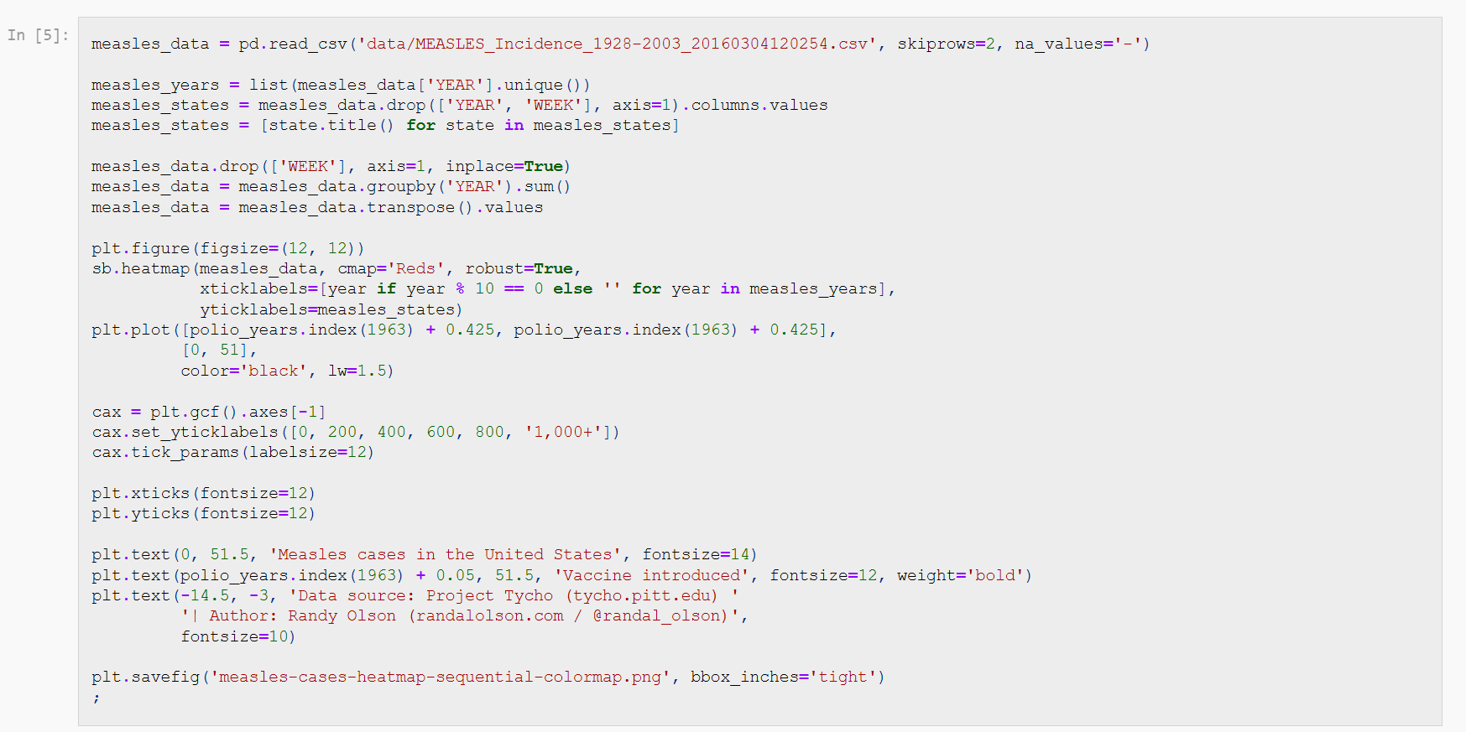

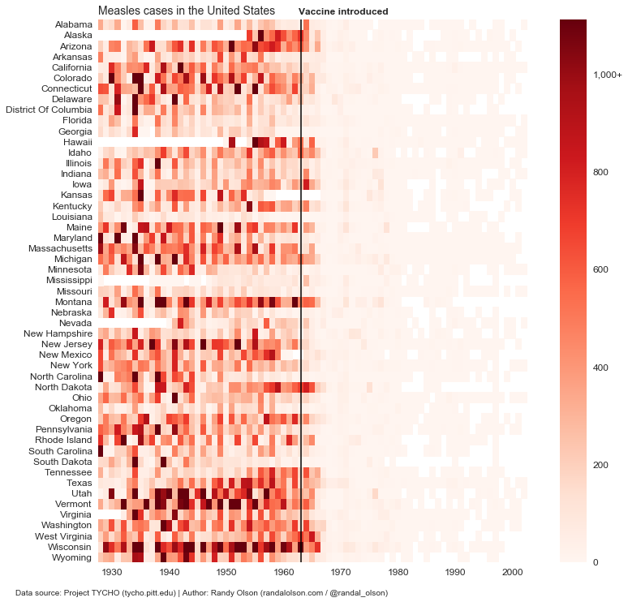

Multi-hue color palettes should take color blindness into account

Color blindness is probably one of the most-overlooked issues in data visualization, and the WSJ heat maps are a great example. I ran the WSJ heat map above through a color blindness simulator for red-green color blindness -- the most common form of color blindness -- and below is the result.

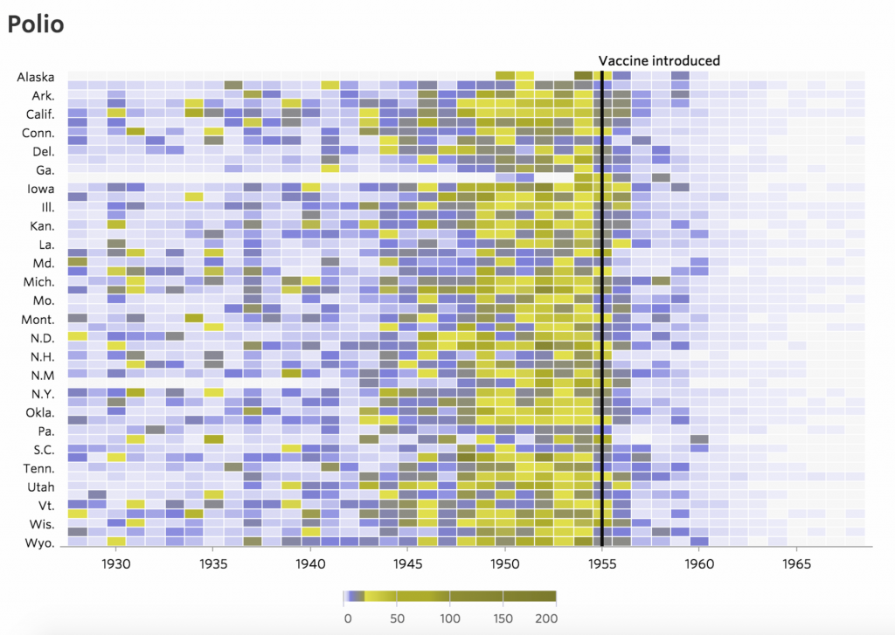

Disastrous! Much of the color gradient is lost in some yellow/grey abyss, and the dark purple colors represent low values whereas the lighter yellow and dark grey colors represent higher values. This color palette survives better than most and the main message is still (mostly) communicated, but the WSJ color palette is certainly far from ideal here.

For comparison, I ran my rework from above through the same red-green color blindness simulator. As we can see, the simple sequential color palette is practically unaffected by this form of color blindness. Problem solved!

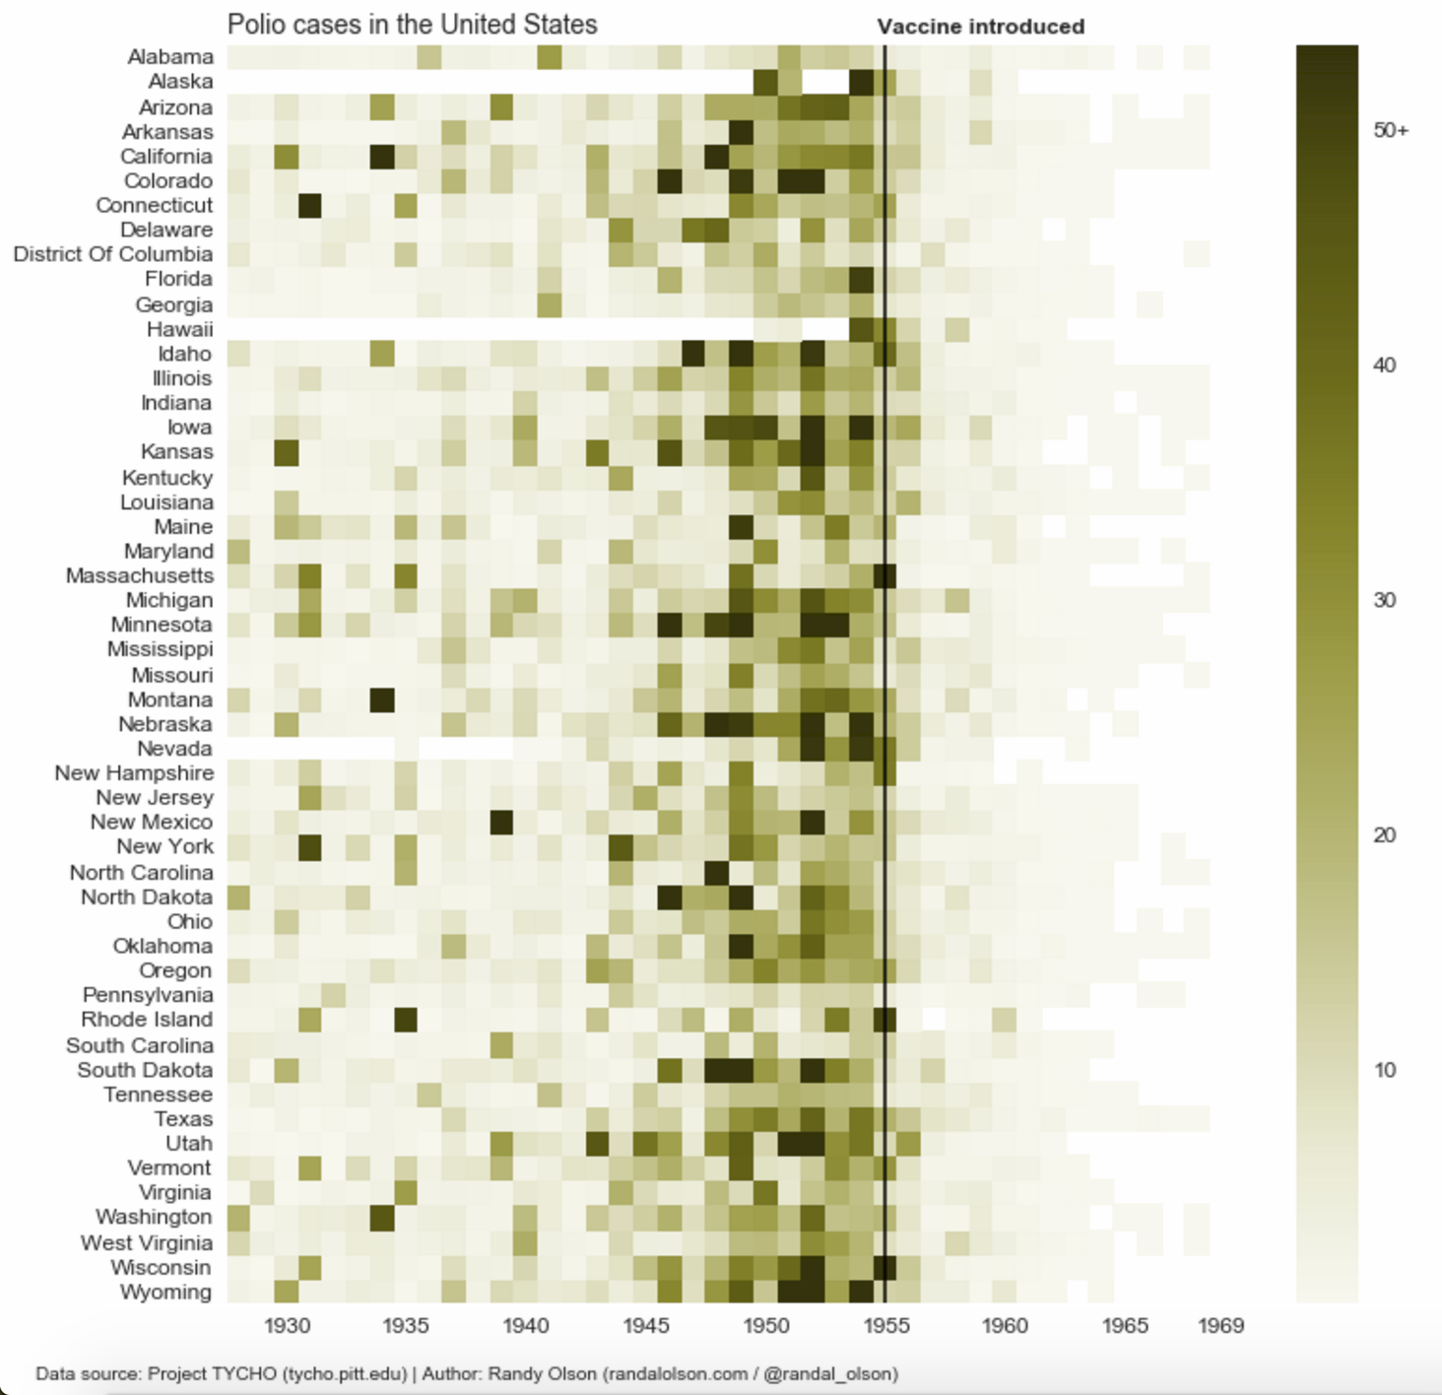

The main lesson here is that we should always run our color palette through a color blindness simulator before committing to it. Roughly 5% of our audience will experience our data visualizations through that lens.
4.The fourth week internship report

Visualize the Polio data as a line chart
One of the major drawbacks of heat maps is that they rely on color to communicate the specific values in each cell. While it's not always important to display a precise value, there can sometimes be important trends hiding in these small differences. For that reason, I reworked the Polio heat map into a simple line chart below, where each light line is a state and the dark line is the median value between all the states for each

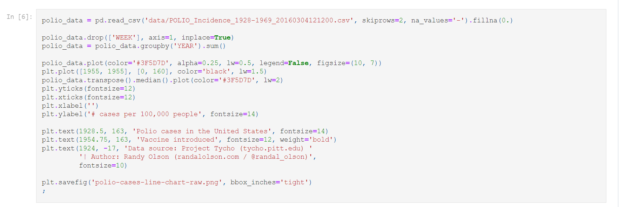
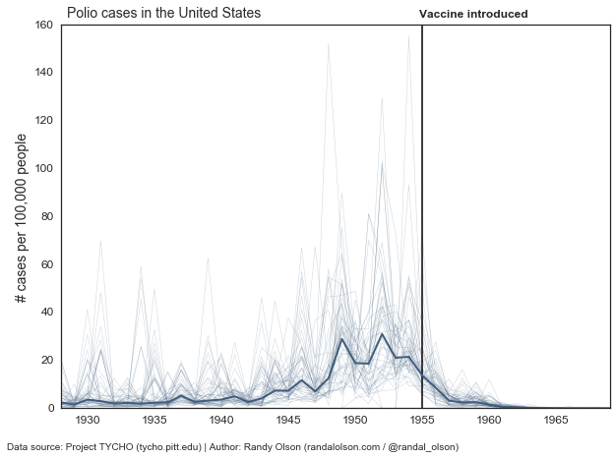

The above chart isn't too useful, and the data is too messy to make much sense of the state-by-state trends. However, the decline in infection rates after the introduction of the vaccine is abundantly clear even in this case.

Summarize Polio data with median + 95% CI
/Users/randal_olson/anaconda/lib/python3.5/site-packages/numpy/lib/function_base.py:3151: RuntimeWarning: Invalid value encountered in median for 2 results RuntimeWarning)

Another fair criticism of all the data visualizations shown so far is that they show too much data. After all, the main message of the WSJ heat maps was simple: When introduced to human populations, vaccines work. There's no need to show the state-by-state trends then; in fact, we may be overwhelming our reader by providing too much data that doesn't get right to the point. For example, what happened with Polio in Utah, with the infection rate more than doubling after the introduction of the Polio vaccine? Or what about South Dakota, where Polio seems to have been mostly eliminated even before the vaccines were made available?
These outliers are distractions to the overall trend. We can overcome these distractions by applying a simple statistical analysis to the data, and show the overall trend with confidence bounds. Below, I've done just that by plotting the median Polio infection rate across all states (dark line) with bootstrapped 95% confidence intervals (shaded area).
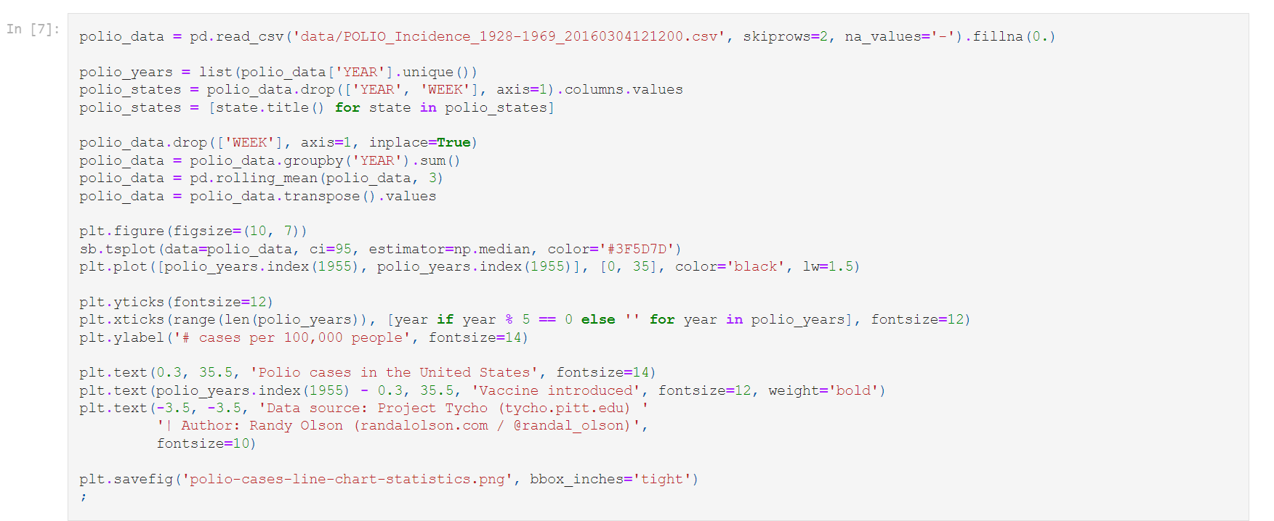

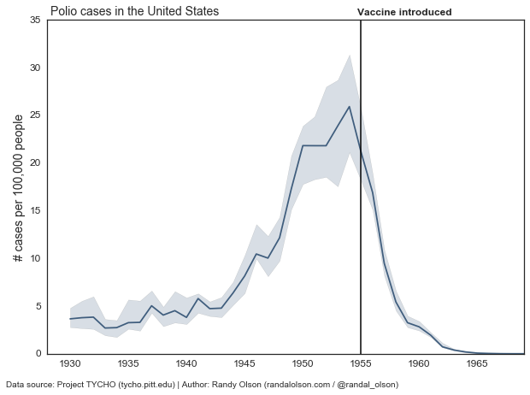

By summarizing the data with some basic statistics, we've removed the distractions and gotten straight to the point: Overall in the U.S., Polio outbreaks were on the rise from the 1940s onward. Right at the introduction of the Polio vaccine in 1955, we immediately saw a decline in Polio outbreaks until it was practically eliminated in the 1960s.

Again, we should always consider our story when designing data visualizations. If we have one clear story that we want to communicate, we should consider reducing the amount of data we show to the point that we can effectively -- and honestly -- communicate our story. There's no point in confusing our reader with unnecessary details, unless those details contain an important caveat.

Display the Polio data as small multiples

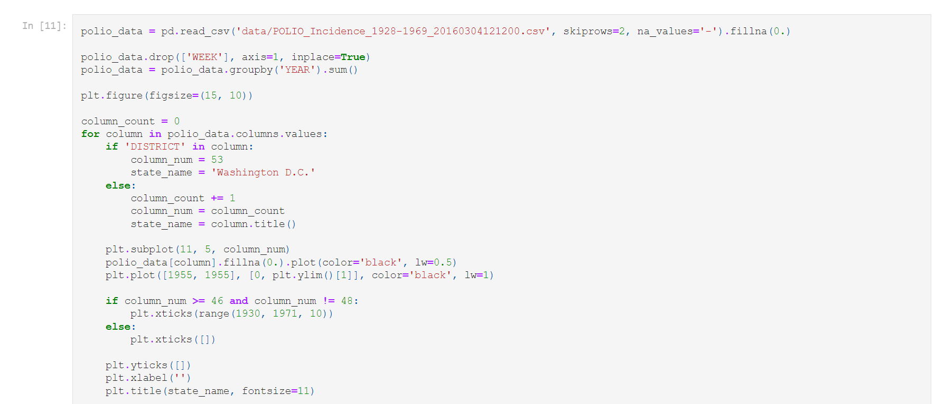



No post of mine is complete without small multiples, so let's give that a try. Below, each state has its own chart, and all 50 states (+ D.C.) are put on the same time axis.

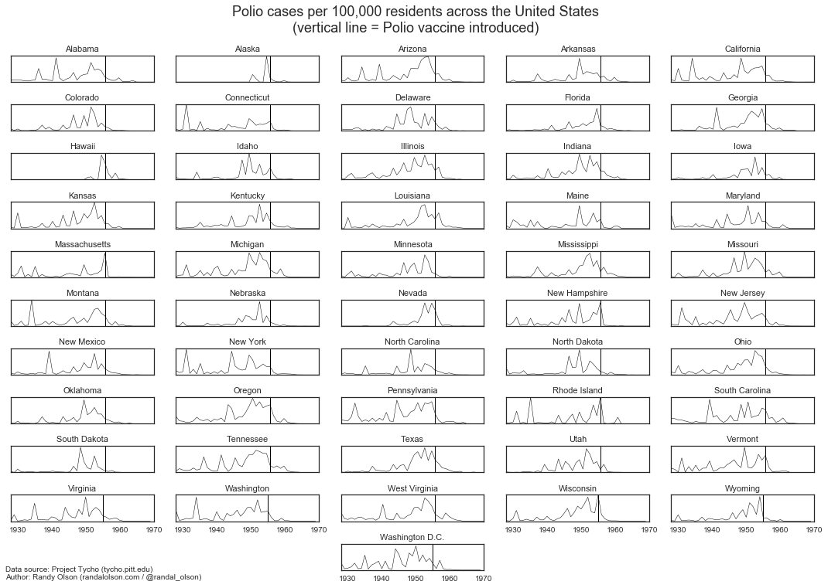Each line tells its own story, and these are stories that were masked in the heat maps. Small multiples allow use to see specific state-by-state trends, for example, Polio outbreaks were already on the decline in South Dakota even before the introduction of the Polio vaccine. Meanwhile, Polio outbreaks were at their worst in New Hampshire just prior to the introduction of the Polio vaccine, which made short order of Polio immediately thereafter.We should always ask ourselves when designing data visualizations: Do we care about the broader story, or the smaller stories? In this case we could go either way, but the direction we go depends on the story we want to tell.In fact demonstrating a proven causal relationship. Please don't waste your time typing out "correlation != causation" in the comments.

5.Internship summary
The first step was to establish a new repository, which was completed. There are a lot of features on GitHub that can help you maintain and enhance the quality of your code. Some of these, like dependency graph and depend a bot alerts, are included in all plans. For GitHub Advanced Security to function on repositories other than the public repositories on GitHub, a license is required for additional security features. The following step involved making a new Branch where I could work very effectively on my GitHub project. This branch contains a wide variety of pages and ideas for our project.

The use of visualizations has been instrumental in depicting the impact and success of polio vaccination programs worldwide. These visual representations have played a vital role in educating the public, promoting vaccination, and celebrating the remarkable strides made in eradicating polio."Revisiting Vaccine Visualizations: Context of Polio" is a comprehensive exploration of the historical and contemporary visual representations associated with polio vaccination campaigns. This analysis delves into the significance of visual communication in shaping public perceptions and attitudes towards immunization efforts.The summary begins by delving into the historical context of polio, highlighting its devastating impact on communities worldwide and the subsequent development of vaccines to combat the disease.

Polio, a highly infectious disease that primarily affects children, was once a global health crisis. However, through widespread vaccination efforts, the disease has been brought under control, with only a few isolated cases remaining. Visualizations have been crucial in highlighting the effectiveness of vaccines and demonstrating the progress made in eliminating polio.we are

One of the key visualizations used in the context of polio vaccination is the mapping of cases. By plotting the distribution of polio cases over time and geography, these maps provide a clear understanding of the disease's spread and concentration. This visualization helps policymakers and health authorities identify high-risk areas and allocate resources accordingly. Additionally, it serves as a powerful tool to demonstrate the impact of vaccination campaigns by showcasing the decline in reported cases over the years.

Another important visualization technique employed is the depiction of vaccination coverage rates. These visualizations illustrate the proportion of the population vaccinated against polio, highlighting areas of success and identifying regions that require further attention. These representations serve as a catalyst for encouraging communities to participate in vaccination drives, emphasizing the importance of herd immunity and the collective responsibility to protect vulnerable individuals.

The article then delves into the various visualizations utilized throughout the decades-long fight against polio. It explores early campaigns that employed simple illustrations and posters to raise awareness and educate the public about the disease and vaccination. These visuals often portrayed polio as a fearsome adversary, emphasizing the need for vaccination as a means of protection.Moving forward in time, the summary discusses the shift towards more diverse and inclusive visual representations.

Furthermore, visualizations play a crucial role in documenting the historical context of polio vaccination campaigns. By presenting timelines and historical data, these visual representations offer insights into the progression of vaccine development, policy implementations, and the overall impact on global health. They provide a visual narrative that emphasizes the dedication of healthcare workers, the collaboration of international organizations, and the perseverance of communities in the fight against polio.

In addition to their educational and historical significance, these visualizations evoke an emotional response from the audience. They humanize the impact of polio by featuring personal stories, images, and testimonials. By showcasing the real-life consequences of the disease and the transformative power of vaccination, these visualizations instill a sense of urgency and empower individuals to take action.

As we move towards the final stages of polio eradication, visualizations continue to play a pivotal role. They not only celebrate the progress achieved but also motivate ongoing efforts to reach the last remaining cases and ensure that future generations remain free from the threat of polio. These visual representations effectively communicate complex data, mobilize public support, and provide a tangible reminder of the transformative impact of vaccines on global health.

In conclusion, the use of visualizations in the context of polio vaccination has been instrumental in educating the public, promoting vaccination, and celebrating the tremendous strides made in eradicating this once-feared disease. By mapping cases, illustrating vaccination coverage rates, documenting historical contexts, and evoking emotional responses, these visualizations have played a vital role in advancing the cause of polio eradication. As we continue to confront global health challenges, visualizations will undoubtedly remain an invaluable tool in shaping public understanding and inspiring action.

To wrap up, these are the lessons we've drawn from revisiting the popularized vaccine visualizations:

1.Use sequential color schemes when presenting continuous values

2.Consider color blindness before committing to a color scheme

3.When presenting specific values is important, don't use color to represent those values

4.Only show enough data to effectively and honestly tell your story

Internship report score sheet
Sequence number | Rating items | Maximum score | score
a | The internship study attitude is serious, and the report meets the template requirements; | 10
b | The report content is comprehensive and the internship process is complete; | 30
c | In-depth analysis of learning content, with unique insights and strong practical ability; | 30
d | Practical tasks completed well； | 20
e | The report is well illustrated and well typed. | 10
 |  | Total score

